 | Willows Termly Newsletter  Autumn Term 2 – 2023  Starts 31st October ends Tuesday 19th Dec 2023 |  | 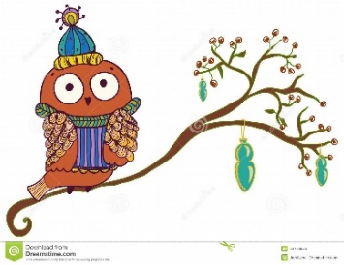
Dear Parents/Carers,
We hope you all had a restful week and that all the children are now ready for a busy time ahead. I wanted to thank all the parents who took the time to arrange a parents’ meeting. I hope it has been very useful and I certainly look forward to continuing working with you. I am positive that with your help we will have a very successful year.
Our Termly Project – Our Festivals and Celebration
This term, taking on from previous learning and children’s interest in birthdays, will explore different celebrations that are important for them, their families and communities. Children will explore festivals and celebrations that take place in autumn and winter, and other events that take place in their own community and in the wider world. Pupils will take part in a variety of creative activities and discover more about how those celebrations vary in every family and community. For example, birthdays, Christmas, Remembrance Day, St Andrews, Halloween and Bonfire night.
Literacy
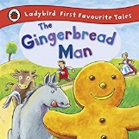
Once more, children will be listening and exploring different texts and stories that will stimulate their imagination and will help them to expand the vocabulary while linking these to our termly project. We will explore in depth the stories Mog’s birthday and the traditional tale The Gingerbread Man.
Phonics
Children will continue their journey through the letter sounds and will start to put two or three sounds together to make simple words. More information regarding phonics will be discussed on our meeting on the 31st Oct.
Book bags
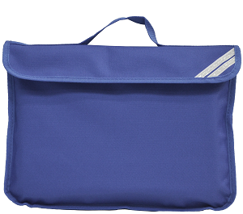
We aim to change Book Bags once a week. This can happen on any day of the week, for this reason book bags need to be brought into school every day. We hope you can share the book with your child, explore unknown vocabulary and record this experience, including children’s comments/progress, in their yellow reading record. Please unless they can read already, DO NOT ask the Little children to read the words in the story book yet. Once they are ready, we will send a separate book for this with a detailed explaination. (See attached sheet)
Maths  As discussed last term, this is a crucial stage for children’s mathematical development. This term, they will continue to develop the skills of counting and recognising number 1 to 6, and later on 6 to 10. Children will also be learning to identify how many objects are in a set of up to 3 or 4 objects without counting and comparing two sets of objects, while verbally telling which has more or less and explaining why. Some children will start to record this work in a written way. |  | Homework  Read –Read- Read plenty of stories to your child and talk about the events in the story, the child’s favourite characters and discuss their thoughts.  In addition, children will continue to have a daily phonics video and a weekly activity to complete in their red homework book, which they will have to complete and return by Wednesday.

Additional Information  Physical Education (PE)  This Autumn 2 term our PE lessons will be on:  Wednesdays afternoon  Children should come to school wearing PE clothes.  This means navy blue or black shorts or tracksuit /jogging bottoms in cooler weather. A white t-shirt and school jumper. No other colour should be worn.  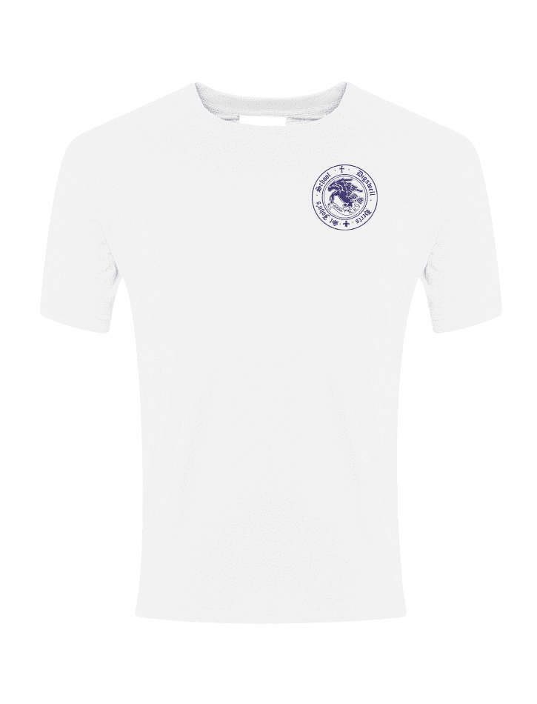 | 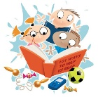  Working in partnership with parents/carers  We recognise that children learn and develop well when there is a strong partnership between staff and parents and/or carers.  For this, we would like to invite you again to join us for a Welly Wednesday session on Wednesday afternoons or on a Thursday morning for a cooking activity. Just let us know the day that suits you best.  Dojo and Website  Our aim is to keep in continuous communication with you. To facilitate this, we encourage you to signing on our class Dojo and keep your Dojo connected to check the updates regularly.  Mrs Perez  https://www.marlborough.plymouth.sch.uk/website
Welly Wednesday
As our PE slot was moved to Wednesdays too, children will need to be come to school wearing their PE clothes and bring their wellies (named) in a bag and a waterproof jacket that they can get muddy and wet.
This will also help children when sitting on the carpet as they are finding very difficult to sit wearing their wellies.

Important Dates

- Halloween Disco - 31st October
- Parents RWI meeting - Tuesday 31st October 9.15
- Nativity Play - Tues 12th Dec – 9.30am and Wed 13th Dec –9.30am
- Last day -Tuesday 19th December

